1. Write a java program to print your biodata?

Code:

class Question1{

    public static void main(String[] args) {

        System.out.println("Name: Pratyush Tripathy");

        System.out.println("College: Indira Gandhi Institute of Technology, Sarang");

        System.out.println("Roll Number: 404036");

        System.out.println("Regd\sNo: 2105105032");

        System.out.println("Branch: MCA");

        System.out.println("Scocity: Mycomp");

        System.out.println("Year: 2021-2023");

    }

}

Output:

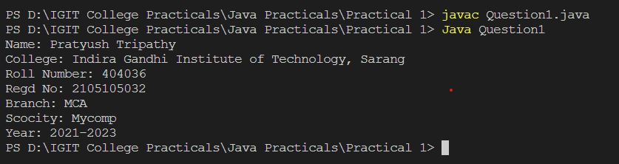

1. Write a java program to find simple interest?

Code:

class Question2 {

    public static void main(String[] args) {

        float principle, rateOfInterest, SI;

        int time;

        principle = 10000;

        rateOfInterest = 8.25f;

        time = 3;

        SI = (principle \* time \* rateOfInterest) / 100;

        System.out.println("Principle: " + principle);

        System.out.println("Time: " + time);

        System.out.println("Rate of Intrest: " +rateOfInterest);

        System.out.println("The Simple Intrest: " + SI);

    }

}

Output:

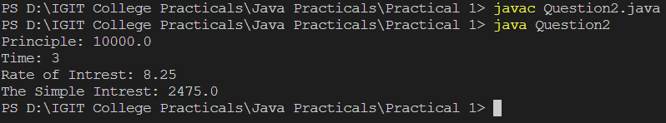

1. Write a java program for temperature conversion?

Code:

class Question3 {

    public static void main(String[] args) {

        float farhenit, celcious;

        celcious = 40;

        farhenit = (celcious \* 9/5) + 32;

        System.out.println("Temperature in Celcious:"+celcious);

        System.out.println("Temperature in farhenit:"+farhenit);

        farhenit = 315;

        celcious = (farhenit - 32) \* 5/9;

        System.out.println("Temperature in farhenit:"+farhenit);

        System.out.println("Temperature in Celcious:"+celcious);

    }

}

Output:

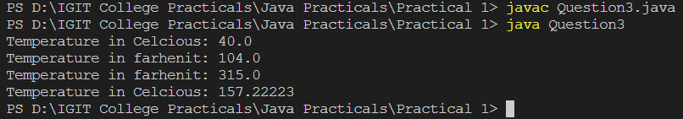

1. Write a java program to implement adder circuit and booth algorithm using bitwise operator?

Code:

import java.util.Scanner;

class Question4 {

    public static void main(String[] args) {

        Scanner in = new Scanner(System.in);

        boolean a, b, c, carry, sum, xor;

        a = true;

        b = true;

        c = false;

        System.out.println("Half Adder");

        sum = a ^ b;

        carry = a & b;

        System.out.println("Value of a is: "+a);

        System.out.println("Value of b is: "+b);

        System.out.println("Value of sum is: "+sum);

        System.out.println("Value of carry is: "+carry);

        System.out.println("Full Adder");

        carry = carry | (sum ^ c);

        sum = sum ^ c;

        System.out.println("Value of a is: "+a);

        System.out.println("Value of b is: "+b);

        System.out.println("Value of c is: "+c);

        System.out.println("Value of sum is: "+sum);

        System.out.println("Value of carry is: "+carry);

        int n, m, temp, output;

        boolean dn1, dn2, dn3, dn4, dm1, dm2, dm3, dm4;

        System.out.print("Enter the number less then 16 in binary: ");

        n = in.nextInt();

        System.out.print("Enter another number less then 16 in binary: ");

        m = in.nextInt();

        temp = 0;

        carry = false;

        output = 0;

        dn1 = n / 1000 == 1 ? true : false;

        dn2 = n / 100 % 10 == 1 ? true : false;

        dn3 = n / 10 % 10 == 1 ? true : false;

        dn4 = n % 10 == 1 ? true : false;

        dm1 = m / 1000 == 1 ? true : false;

        dm2 = m / 100 % 10 == 1 ? true : false;

        dm3 = m / 10 % 10 == 1 ? true : false;

        dm4 = m % 10 == 1 ? true : false;

        xor = dn4 ^ dm4;

        sum =  xor ^ carry;

        carry = (xor & carry) | (dn4 & dm4);

        temp = temp \* 10 + (sum ? 1: 0);

        xor = dn3 ^ dm3;

        sum =  xor ^ carry;

        carry = (xor & carry) | (dn3 & dm3);

        temp = temp \* 10 + (sum ? 1: 0);

        xor = dn2 ^ dm2;

        sum =  xor ^ carry;

        carry = (xor & carry) | (dn2 & dm2);

        temp = temp \* 10 + (sum ? 1: 0);

        xor = dn1 ^ dm1;

        sum =  xor ^ carry;

        carry = (xor & carry) | (dn1 & dm1);

        temp = temp \* 10 + (sum ? 1: 0);

        output = carry ? 1 : 0;

        output = Integer.parseInt(String.valueOf(output)+String.valueOf(temp));

        System.out.println("The value is: "+output);

        in.close();

    }

}

Output:

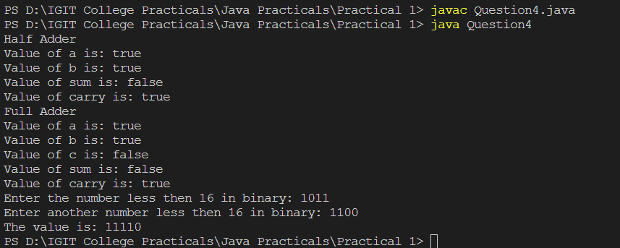

1. A. Sum of all digits of any 4 digit numbers

Code:

class Question5a {

    public static void main(String[] args) {

        int num, sum;

        num = 3971;

        sum = (num % 10) + (num % 100 / 10) + (num % 1000 / 100) + (num / 1000);

        System.out.println("The sum of " + num + " is: " + sum);

    }

}

Output:



5.B. find the face value and position value of any 4 digit number?

Code:

class Question5b {

    public static void main(String[] args) {

        int num;

        num = 6319;

        System.out.println("First number\n\tface value:"+(num/1000)+" \n\tposition value: "+(num - num % 1000));

        System.out.println("First number\n\tface value:"+(num/100%10)+" \n\tposition value: "+(num/100%10 \* 100));

        System.out.println("First number\n\tface value:"+(num/10%10)+" \n\tposition value: "+(num/10%10 \* 10));

        System.out.println("First number\n\tface value:"+(num%10)+" \n\tposition value: "+(num%10));

    }

}

Output:

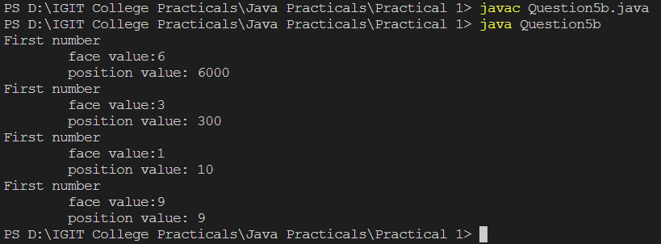

5.C. Find the value available at position required by user it may be 10, 100 or 1000?

Code:

class Question5c {

    public static void main(String[] args) {

        int num;

        num = 6198;

        System.out.println("The number: "+num);

        System.out.println("Value available at position 1000: "+(num/1000));

        System.out.println("Value available at position 100: "+(num/100%10));

        System.out.println("Value available at position 10: "+(num/10%10));

        System.out.println("Value available at position 1: "+(num%10));

    }

}

Output:

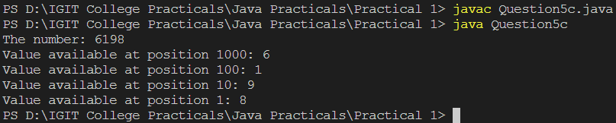

5.D. Sum of product of consecutive digits of any 4 digit number? Suppose num=1234 then output= 4\*3+3\*2+2\*1

Code:

class Question5d {

    public static void main(String[] args) {

        int num, sum, num1, num2, num3, num4;

        num = 1234;

        num1 = num / 1000;

        num2 = num / 100 % 10;

        num3 = num / 10 % 10;

        num4 = num % 10;

        sum = (num1 \* num2) + (num2 \* num3) + (num3 \* num4);

        System.out.println("The number: " + num);

        System.out.println("Sum of product of consecutive digits: " + sum);

    }

}

Output:

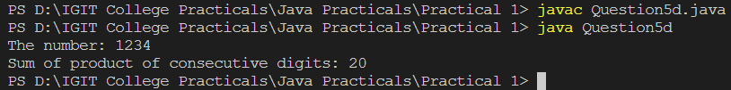

5.E. find sum of product of corresponding digits of two any 4 digit number Such as n=1234 m=7896 output = 6\*4+9\*3+8\*2+7\*1 ?

Code:

class Question5e {

    public static void main(String[] args) {

        int num1, num2, sum;

        int n1d1, n1d2, n1d3, n1d4;

        int n2d1, n2d2, n2d3, n2d4;

        num1 = 1234;

        num2 = 7896;

        n1d1 = num1 / 1000;

        n1d2 = num1 / 100 % 10;

        n1d3 = num1 / 10 % 10;

        n1d4 = num1 % 10;

        n2d1 = num2 / 1000;

        n2d2 = num2 / 100 % 10;

        n2d3 = num2 / 10 % 10;

        n2d4 = num2 % 10;

        sum = n1d1\*n2d1 + n1d2\*n2d2 + n1d3\*n2d3 + n1d4\*n2d4;

        System.out.println("First Number: "+num1);

        System.out.println("Second Number: "+num2);

        System.out.println("Sum of product of corresponding digits of the two number is: "+sum);

    }

}

Output:

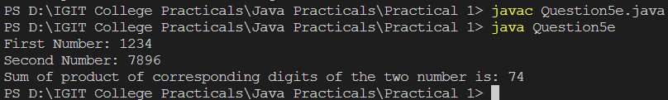

5.F. find bitwise and , or , and xor of 2nd and 4th digit of any 4 digit number?

Code:

class Question5f {

    public static void main(String[] args) {

        int num, d2, d4;

        num = 2386;

        d2 = num / 100 % 10;

        d4 = num % 10;

        System.out.println("The number is: " + num);

        System.out.println("Bitwise and of 2nd and 4th digit: " + (d2 & d4));

        System.out.println("Bitwise or of 2nd and 4th digit: " + (d2 | d4));

        System.out.println("Bitwise xor of 2nd and 4th digit: " + (d2 ^ d4));

    }

}

Output:

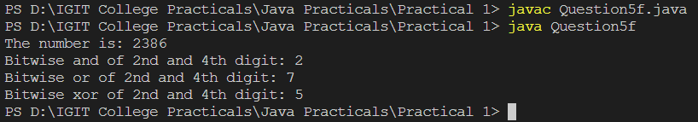

5.G. Find left shit, right shift and zero fill of summation of all digits of any 4 digit number and it will be shifted by 3rd digit of any 4 digit number?

Code:

class Question5g {

    public static void main(String[] args) {

        int num, sum, d1, d2, d3, d4;

        num = 9728;

        d1 = num / 1000;

        d2 = num / 100 % 10;

        d3 = num / 10 % 10;

        d4 = num % 10;

        sum = d1 + d2 + d3 + d4;

        System.out.println("The number is: " + num);

        System.out.println("The Sum of the digits is: " + sum);

        System.out.println("Left shift upto " + d3 + " to sum is: " + (sum << d3));

        System.out.println("Right shift upto " + d3 + " to sum is: " + (sum >> d3));

        System.out.println("Right shift and zero fill upto " + d3 + " to sum is: " + (sum >>> d3));

    }

}

Output:

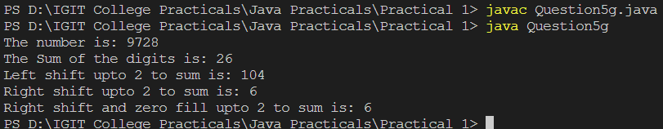

1. A. Sum of all even digits of any 4 digit number?

Code:

class Question6a {

    public static void main(String[] args) {

        int num, sum, d1, d2, d3, d4;

        num = 4187;

        sum = 0;

        d1 = num / 1000;

        d2 = num / 100 % 10;

        d3 = num / 10 % 10;

        d4 = num % 10;

        sum += d1 % 2 == 0 ? d1 : 0;

        sum += d2 % 2 == 0 ? d2 : 0;

        sum += d3 % 2 == 0 ? d3 : 0;

        sum += d4 % 2 == 0 ? d4 : 0;

        System.out.println("The number is: "+num);

        System.out.println("Sum of the all even digits of the number is: "+sum);

    }

}

Output:

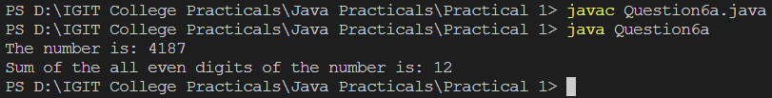

6.B. Sum of all odd digits of any 4 digit number

Code:

class Question6b {

    public static void main(String[] args) {

        int num, sum, d1, d2, d3, d4;

        num = 4187;

        sum = 0;

        d1 = num / 1000;

        d2 = num / 100 % 10;

        d3 = num / 10 % 10;

        d4 = num % 10;

        sum += d1 % 2 != 0 ? d1 : 0;

        sum += d2 % 2 != 0 ? d2 : 0;

        sum += d3 % 2 != 0 ? d3 : 0;

        sum += d4 % 2 != 0 ? d4 : 0;

        System.out.println("The number is: " + num);

        System.out.println("Sum of the all odd digits of the number is: " + sum);

    }

}

Output:

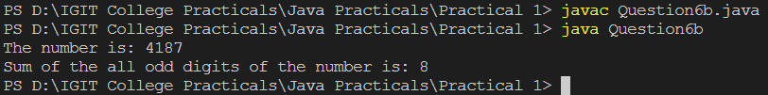

6.C. Difference between average of all even digits except divisible by 4 and avearge of all odd digits except divisble by 3 of any 4 digit number

Code:

class Question6c {

    public static void main(String[] args) {

        int num, d1, d2, d3, d4;

        int avgEvenCount = 0, avgOddCount = 0;

        float diff, avgEven, avgOdd;

        num = 6275;

        d1 = num / 1000;

        d2 = num / 100 % 10;

        d3 = num / 10 % 10;

        d4 = num % 10;

        avgEven = 0;

        avgOdd = 0;

        avgOddCount += (d1 % 2 == 0) && (d1 %4 != 0) ? 0 : 1;

        avgEven += (d1 % 2 == 0) && (d1 %4 != 0) ? d1 : 0;

        avgOddCount += (d2 % 2 == 0) && (d2 %4 != 0) ? 0 : 1;

        avgEven += (d2 % 2 == 0) && (d2 %4 != 0) ? d2 : 0;

        avgOddCount += (d3 % 2 == 0) && (d3 %4 != 0) ? 0 : 1;

        avgEven += (d3 % 2 == 0) && (d3 %4 != 0) ? d3 : 0;

        avgOddCount += (d4 % 2 == 0) && (d4 %4 != 0) ? 0 : 1;

        avgEven += (d4 % 2 == 0) && (d4 %4 != 0) ? d4 : 0;

        // avg odd

        avgEvenCount += (d1 % 2 != 0) && (d1 %3 != 0) ? 0 : 1;

        avgOdd += (d1 % 2 != 0) && (d1 %3 != 0)  ? d1 : 0;

        avgEvenCount += (d2 % 2 != 0) && (d2 %3 != 0) ? 0 : 1;

        avgOdd += (d2 % 2 != 0) && (d2 %3 != 0) ? d2 : 0;

        avgEvenCount += (d3 % 2 != 0) && (d3 %3 != 0) ? 0 : 1;

        avgOdd += (d3 % 2 != 0) && (d3 %3 != 0) ? d3 : 0;

        avgEvenCount += (d4 % 2 != 0) && (d4 %3 != 0) ? 0 : 1;

        avgOdd += (d4 % 2 != 0) && (d4 %3 != 0) ? d4 : 0;

        avgEven /= avgEvenCount;

        avgOdd /= avgOddCount;

        diff = avgEven - avgOdd;

        System.out.println("Number is: "+num);

        System.out.println("The difference is: "+diff);

    }

}

Output:

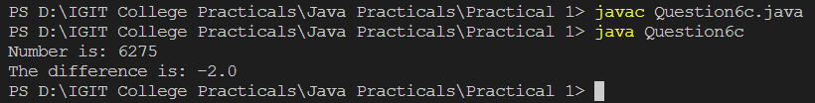

6.D. Sum of product of consecutive even digits of any 4 digit number? Suppose num=1624 then output= 4\*2+2\*6

Code:

class Question6d {

    public static void main(String[] args) {

        int num, sum;

        int d1, d2, d3, d4;

        num = 1624;

        sum = 0;

        d1 = num / 1000;

        d2 = num / 100 % 10;

        d3 = num / 10 % 10;

        d4 = num % 10;

        sum += d1 % 2 == 0 && d2 % 2 == 0  ? d1 \* d2 : 0;

        sum += d2 % 2 == 0 && d3 % 2 == 0  ? d2 \* d3 : 0;

        sum += d3 % 2 == 0 && d4 % 2 == 0  ? d3 \* d4 : 0;

        System.out.println("Sum of product of consecutive even digits: "+sum);

    }

}

Output:

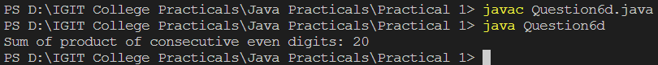

6.E. Sum of product of consecutive odd digits of any 4 digit number? Suppose num=1356 then output= 5\*3+ 3\*1

Code:

class Question6e {

    public static void main(String[] args) {

        int num, sum;

        int d1, d2, d3, d4;

        num = 1356;

        sum = 0;

        d1 = num / 1000;

        d2 = num / 100 % 10;

        d3 = num / 10 % 10;

        d4 = num % 10;

        sum += d1 % 2 != 0 && d2 % 2 != 0  ? d1 \* d2 : 0;

        sum += d2 % 2 != 0 && d3 % 2 != 0  ? d2 \* d3 : 0;

        sum += d3 % 2 != 0 && d4 % 2 != 0  ? d3 \* d4 : 0;

        System.out.println("Sum of product of consecutive odd digits: "+sum);

    }

}

Output:



6.F. Difference between Sum of product of consecutive even digits except 2 and 6 and Sum of product of consecutive odd digits except 3 and 7 of any 4 digit number

Code:

import java.util.Scanner;

class Question6f {

    public static void main(String[] args) {

        Scanner in = new Scanner(System.in);

        int num, d1, d2, d3, d4, sumOdd, sumEven, diff;

        System.out.println("Enter the 4 digit Number: ");

        num = in.nextInt();

        diff = 0;

        sumOdd = 0;

        sumEven = 0;

        d1 = num / 1000;

        d2 = num / 100 % 10;

        d3 = num / 10 % 10;

        d4 = num % 10;

        sumEven += ( d1 % 2 == 0 && d1 != 2 && d1 != 6 ) && ( d2 % 2 == 0 && d2 != 2 && d2 != 6 ) ? d1 \* d2 : 0;

        sumEven += ( d2 % 2 == 0 && d2 != 2 && d2 != 6 ) && ( d3 % 2 == 0 && d3 != 2 && d3 != 6 ) ? d2 \* d3 : 0;

        sumEven += ( d3 % 2 == 0 && d3 != 2 && d3 != 6 ) && ( d4 % 2 == 0 && d4 != 2 && d4 != 6 ) ? d3 \* d4 : 0;

        sumOdd += ( d1 % 2 != 0 && d1 != 3 && d1 != 7 ) && ( d2 % 2 != 0 && d2 != 3 && d2 != 7 ) ? d1 \* d2 : 0;

        sumOdd += ( d2 % 2 != 0 && d2 != 3 && d2 != 7 ) && ( d3 % 2 != 0 && d3 != 3 && d3 != 7 ) ? d2 \* d3 : 0;

        sumOdd += ( d3 % 2 != 0 && d3 != 3 && d3 != 7 ) && ( d4 % 2 != 0 && d4 != 3 && d4 != 7 ) ? d3 \* d4 : 0;

        diff = sumEven - sumOdd;

System.out.println("The sum of all Even Digits: "+sumEven);

        System.out.println("The sum of all Odd Digits: "+sumOdd);

        System.out.println("The difference is: "+diff);

        in.close();

    }

}

Output:

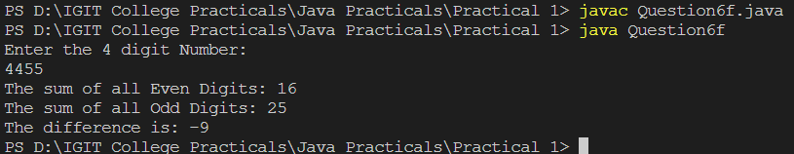

6.G. Write a java program to find sum of product of corresponding even digits of first any digit number and corresponding odd digit of any 4 digit number Such as n=1234 m=4567 output=4\*7+2\*5

Code:

import java.util.Scanner;

class Question6g {

    public static void main(String[] args) {

        Scanner in = new Scanner(System.in);

        int n,m, dn1, dn2, dn3, dn4, dm1, dm2, dm3, dm4, sum;

        System.out.print("Enter the first Number: ");

        n = in.nextInt();

        System.out.print("Enter the second Number: ");

        m = in.nextInt();

        sum = 0;

        dn1 = n / 1000;

        dn2 = n / 100 % 10;

        dn3 = n / 10 % 10;

        dn4 = n % 10;

        dm1 = m / 1000;

        dm2 = m / 100 % 10;

        dm3 = m / 10 % 10;

        dm4 = m % 10;

        sum += (dn1 %2 == 0) && (dm1 %2 != 0) ? dn1 \* dm1 : 0;

        sum += (dn2 %2 == 0) && (dm2 %2 != 0) ? dn2 \* dm2 : 0;

        sum += (dn3 %2 == 0) && (dm3 %2 != 0) ? dn3 \* dm3 : 0;

        sum += (dn4 %2 == 0) && (dm4 %2 != 0) ? dn4 \* dm4 : 0;

        System.out.println("The sum value is: "+sum);

        in.close();

    }

}

Output:

